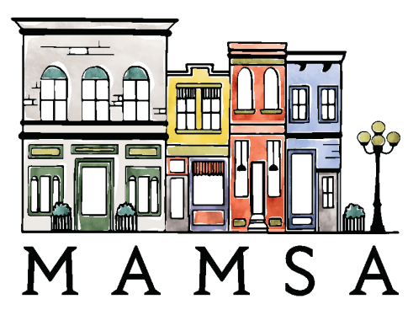
Mount Airy Main Street Association
Request for Funds Application

Business / Name of Organization:
Street Address:
City: Zip Code:
Email: Phone:
Amount Requested:
How Will The Funds Be Used?

Signature: Date:
The Mount Airy Main Street Association, Board of Directors, meets on the 2nd or 3rd Tuesday of every month. “Request for Funds” applications will be reviewed ONLY at those meetings; you will be notified of the meeting date when your application is received. A member of Board of Directors will contact you within 24 hours after the meeting to notify you of their decision.
MAMSA Mission Statement
MAMSA members are a dedicated group of volunteer residents and business owners interested in working with the town and other stakeholders to revitalize Mount Airy’s historic downtown business district. MAMSA strives to establish downtown as a gathering place and center of community life, promote commerce for local businesses, sponsor cultural events for residents and visitors, and create a small town destination that is easily accessible by car, bike and foot.

